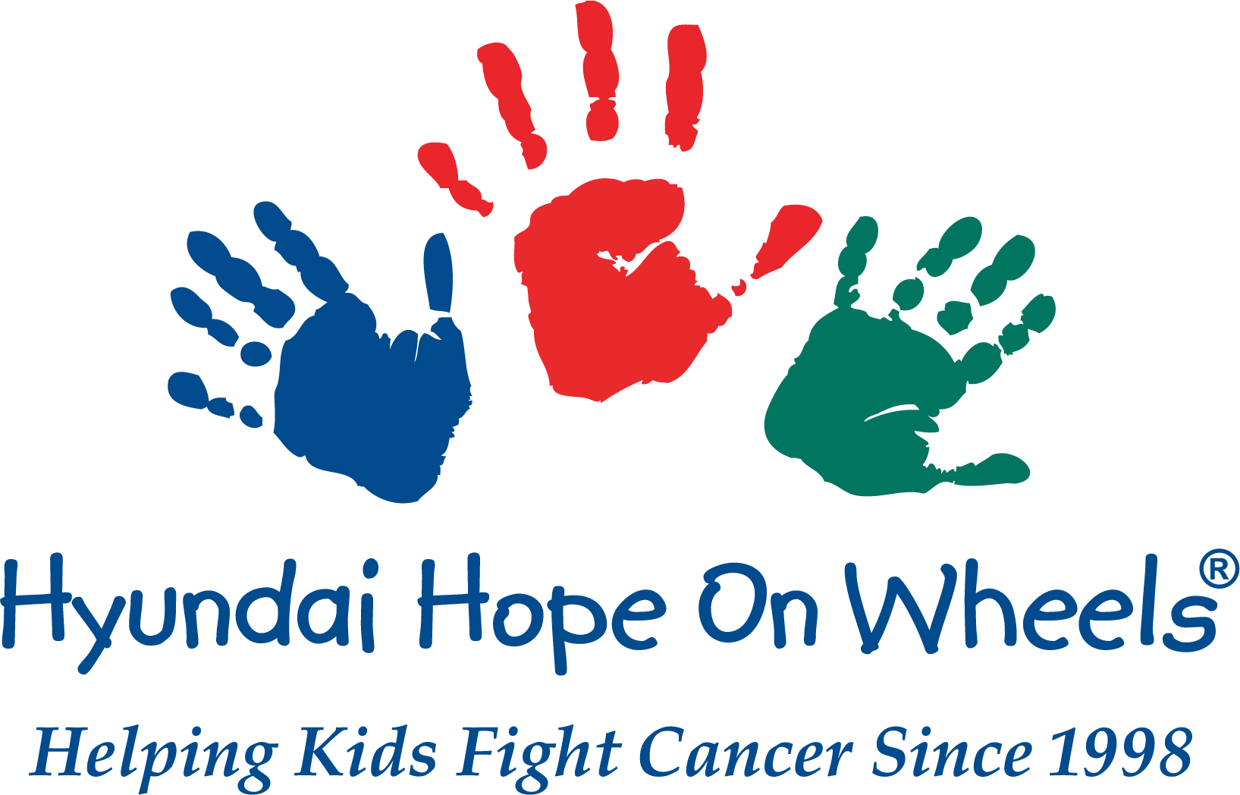
- Name:
- Age:
- Date of Birth:
- Hometown:
- Type of Cancer:
- Age of Diagnosis / Please describe how you first learned of your child’s diagnosis:
- Primary Treatment Hospital:
- Current Medical Status:
- Favorite hobbies, books, movies, or other personal information:
- Words of wisdom or experiences to share with other children battling cancer:
- As the parent/guardian, please describe how pediatric cancer has affected your family. What message of hope would you give to other families going through a diagnosis of pediatric cancer:
- Please write a short essay (300 words or less) on why you would like to be the 2020-2021 Hyundai Hope on Wheels National Youth Ambassador:
- Have you participated in media interviews in the past (if so, for who)? If links are available, please share:

